# W2D2 Homework

# Question 1

Table emp, order by ename increasing，which one or more are correct?

A.select ename , salary from emp   order by ename asc

B.select ename , salary from emp   order by ename desc

C.select ename , salary from emp   order by salary asc

D.select ename , salary from emp   order by ename  ;

# Question 2

Table EMPLOYEES

EMPLOYEE_ID        NUMBER          Primary Key FIRST_NAME             VARCHAR2(25) LAST_NAME              VARCHAR2(25)

Which one insert one record to the table correctly?

A. INSERT INTO employees(employee_id) VALUES (1000);

B. INSERT INTO employees (first_name,last_name) VALUES (‘John’,’Smith’);

 C. INSERT INTO employees VALUES(1000,’John’,’NULL’);

D. INSERT INTO employees VALUES (‘1000’,’John’);

# Question 3

SELECT name, rank, serialNo FROM employee.

Which one to get the value of first column of rs?

A. rs.getString(0);

B. rs.getString("name");

C. rs.getString(1);

D. rs.getString(“ename”);

# Question4

At first in database, create a table Employee, id is primary key.

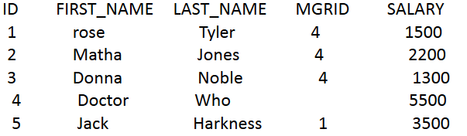

*create table Employee(id Number(11,0) Primary Key NOT NULL, first_name varchar(20), last_name varchar(20), mgrid number(11,0), salary float);*

1. Create a table, and insert a record to the table, and print out all the data in the table

(6 Alex Lee 1 4500)

1. Modify the last_name to “Tate” whose last_name is “Jones” , and save it to database. And print out all the data in the table.

Answer for (1 & 2) is in java source code in git

# Question 5

Why we use Class.forName?

-It ensures the class is loaded and it does not do anything for the connection to the DB  
there should be a try&catch/throws to catch the exception if it is unable to load the Class.

# Question 6

What’s the difference between Statement and PreparedStatement?

-Statement will always proceed to get the Sql then compile the sql then execute it.  
PreparedStatement is a much more powerful Statement because you can optimize the sql by using “?” to insert values to the sql before executing.

# Question 7

How to close the resultset, statement and connection after we finished the database operation? Write the codes.

Connection.close();

Statement.close(); or PreparedStatement.close();

ResultSet.Close();